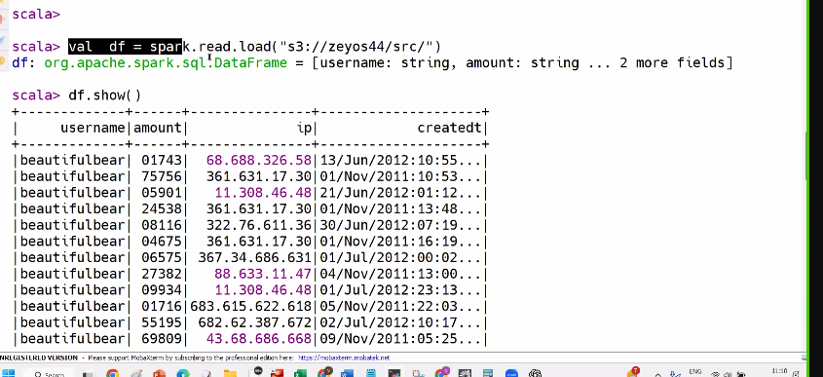
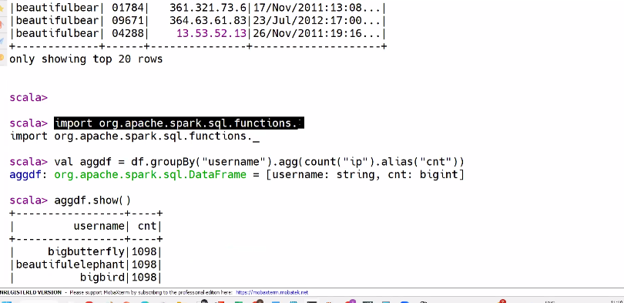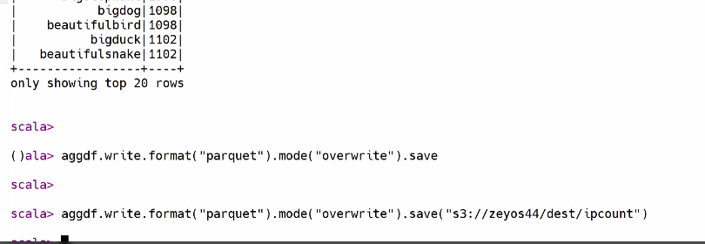
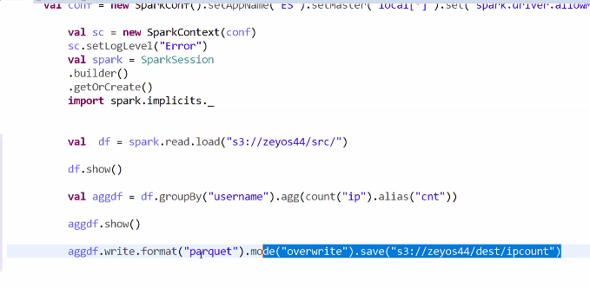

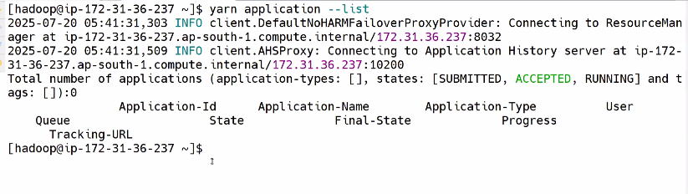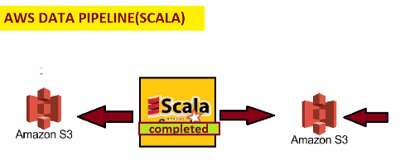
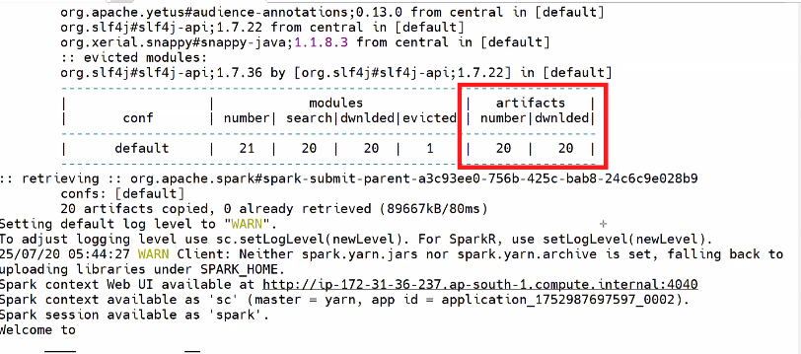
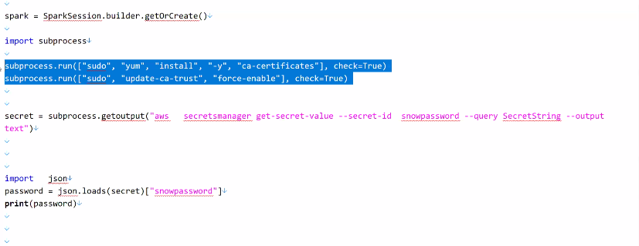
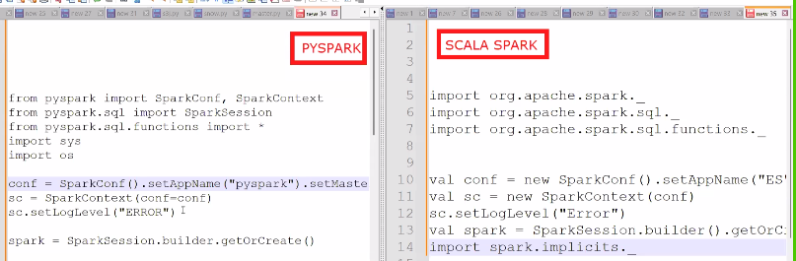
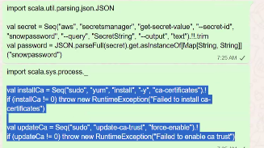
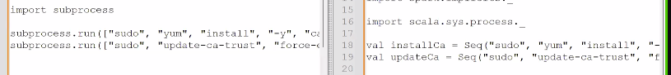
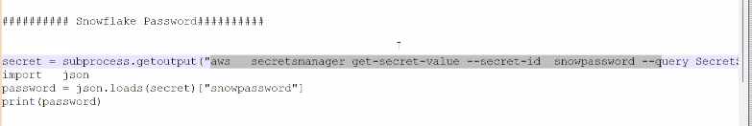
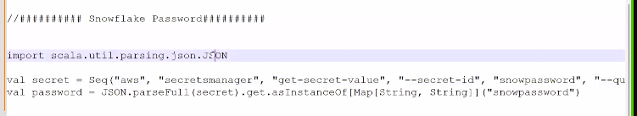
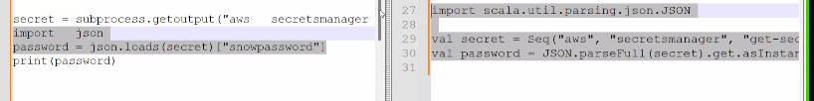
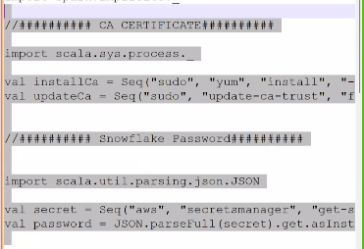
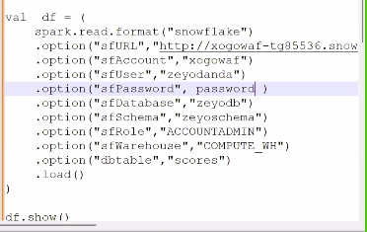
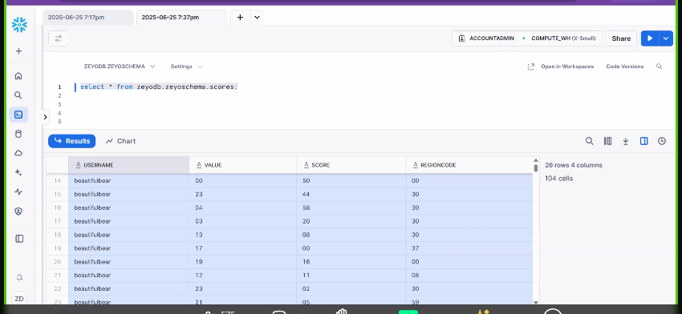
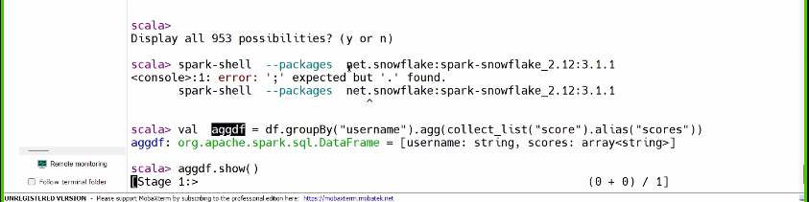

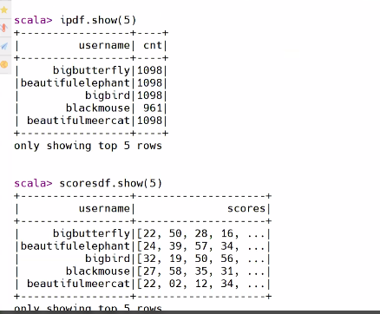
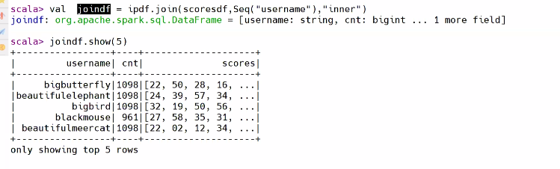
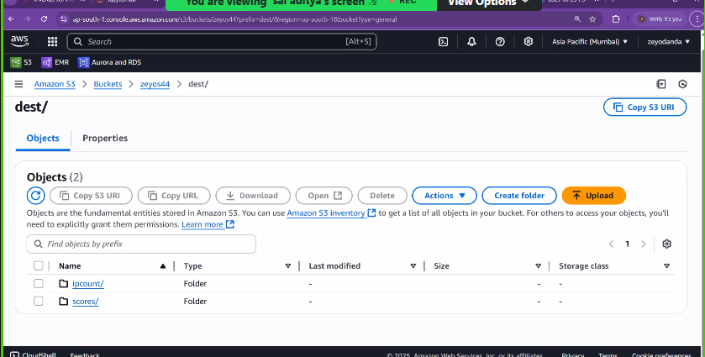
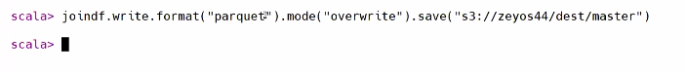
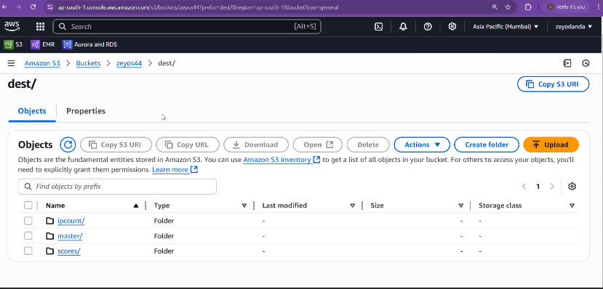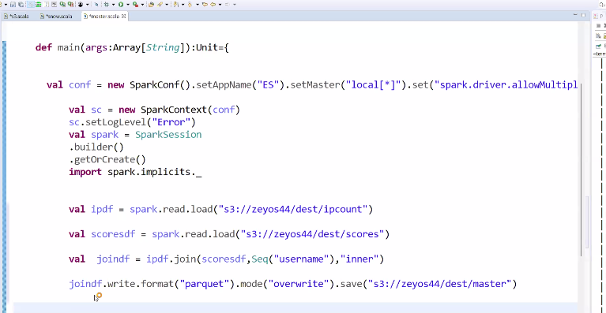
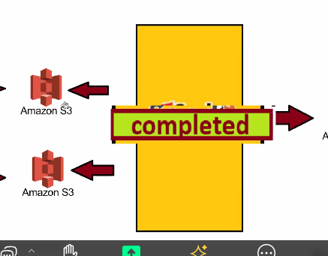
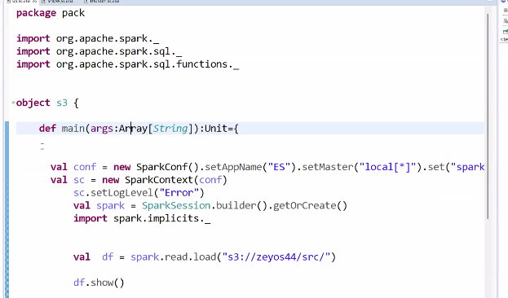
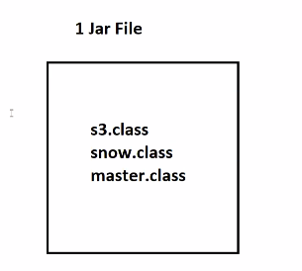
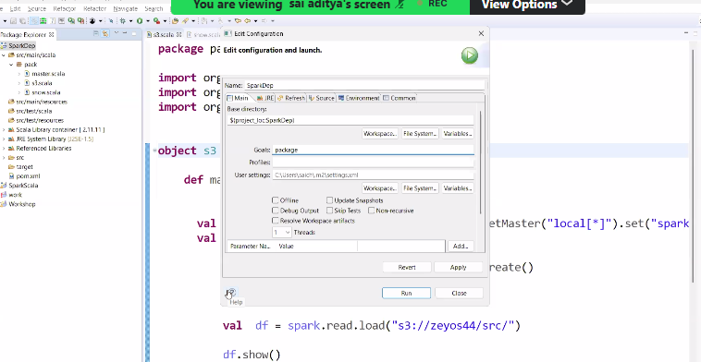
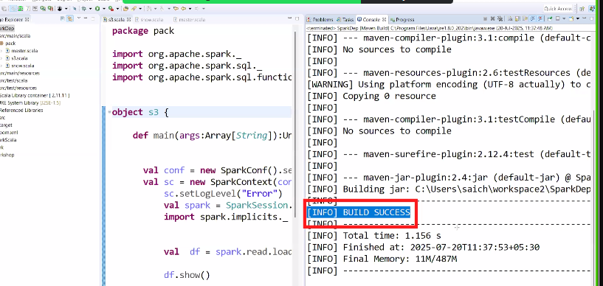
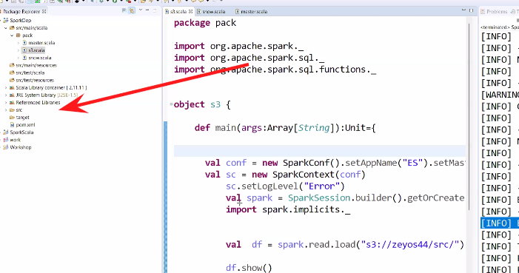
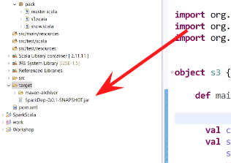
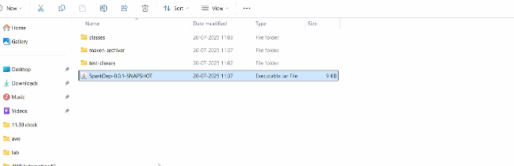
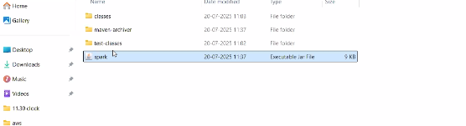
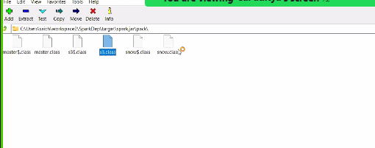
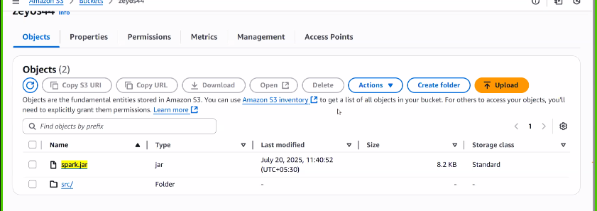
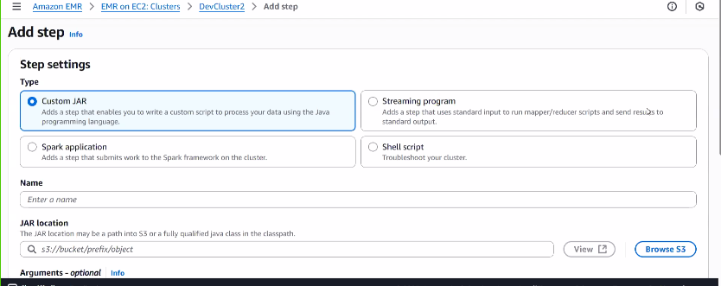
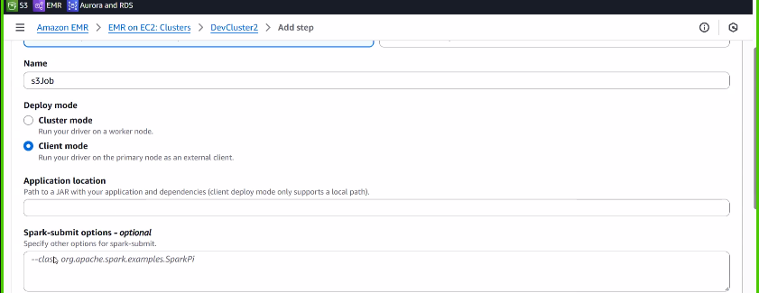
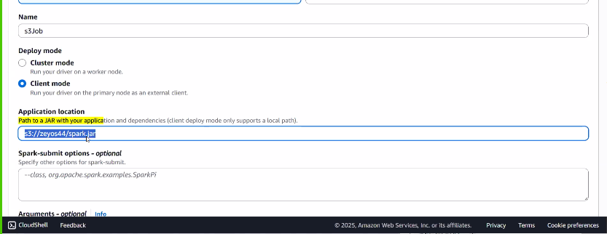
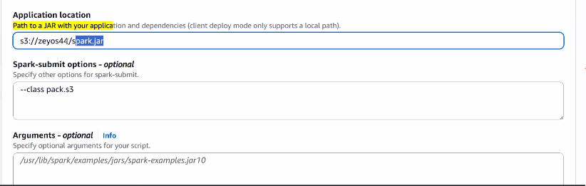
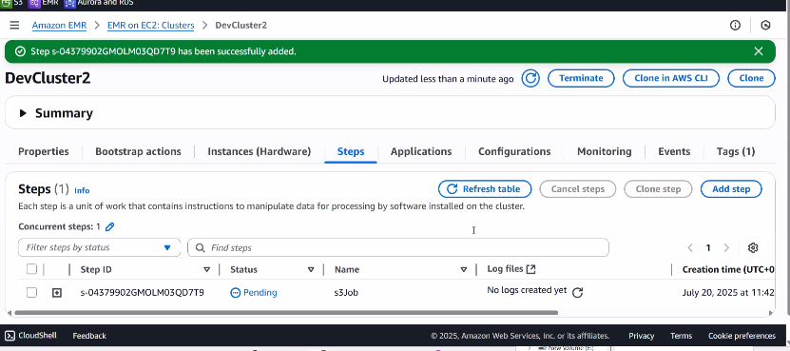
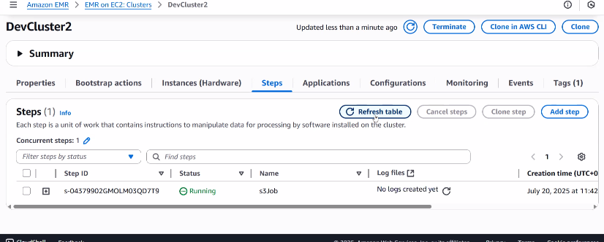
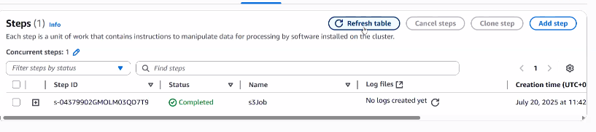
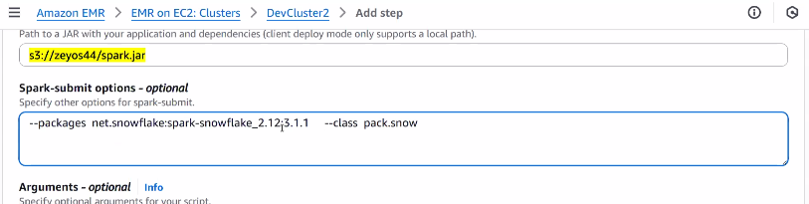
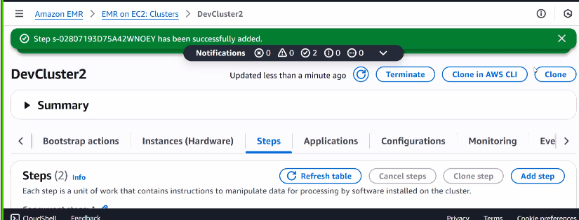
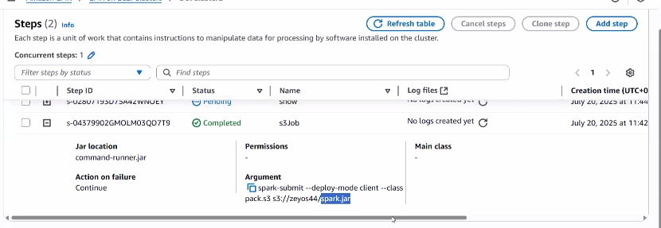
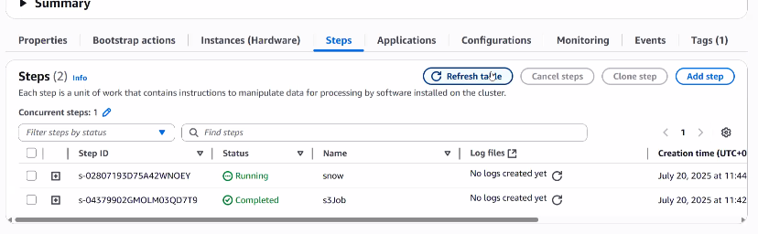
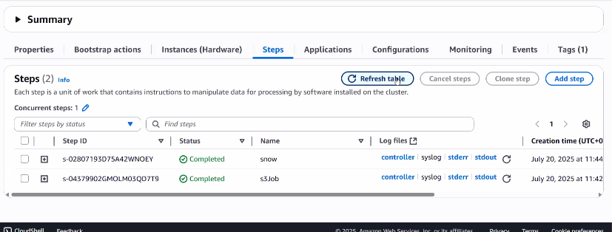
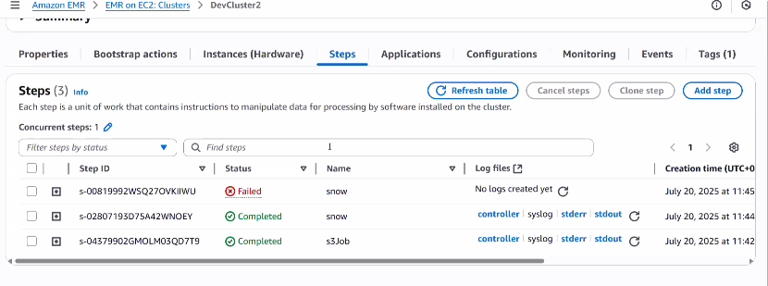
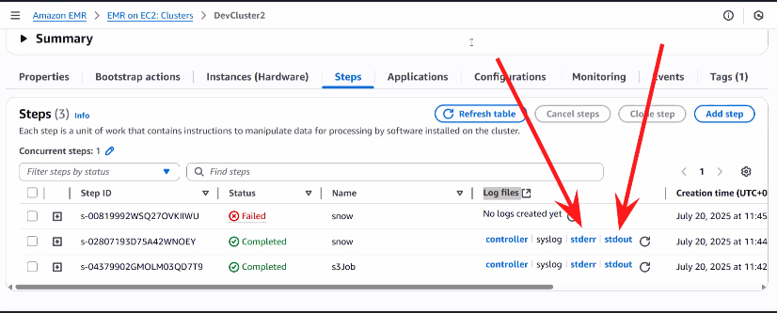
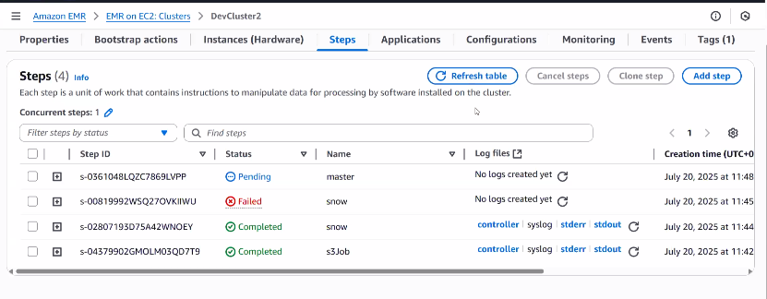
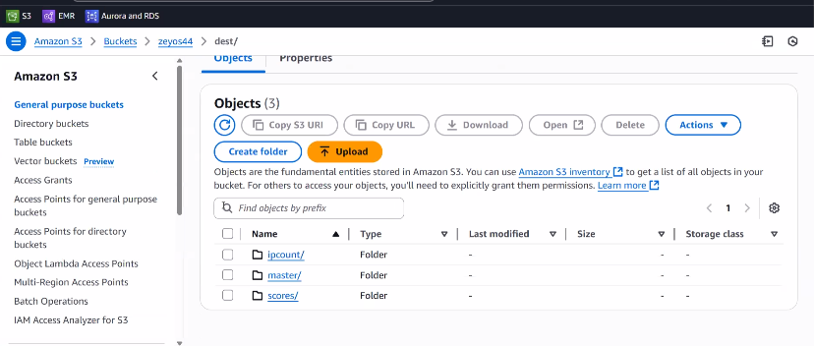
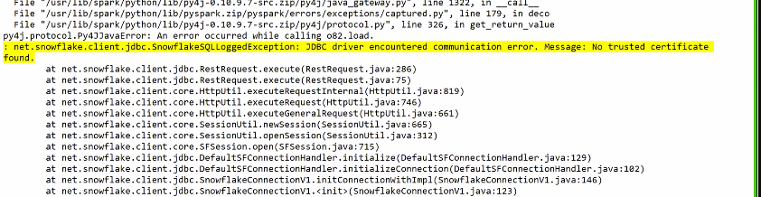
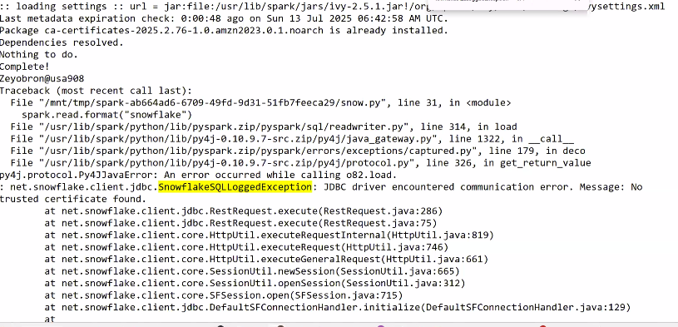
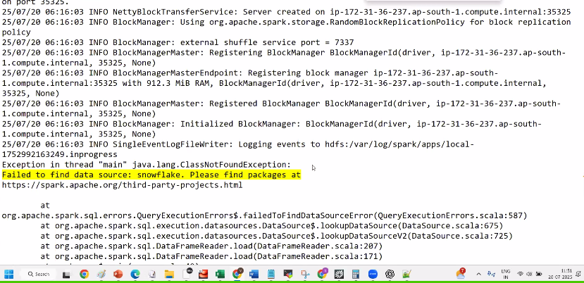
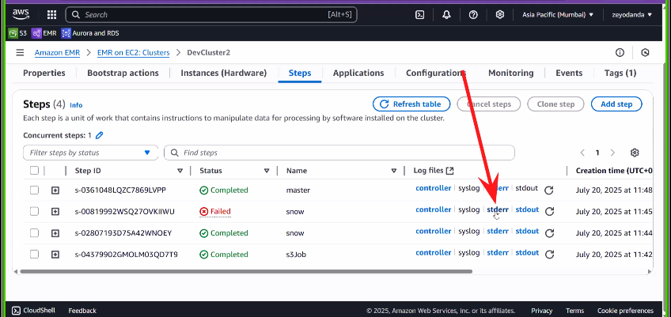
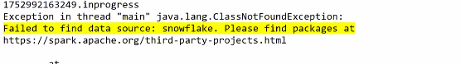
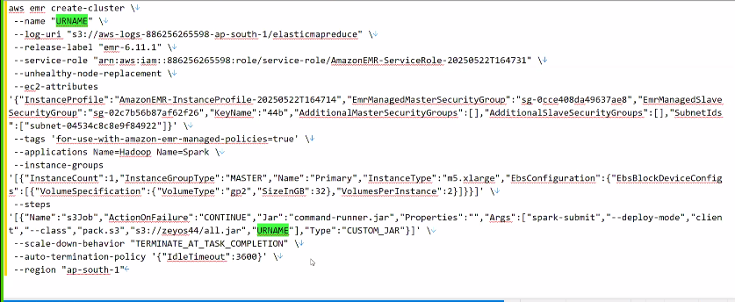
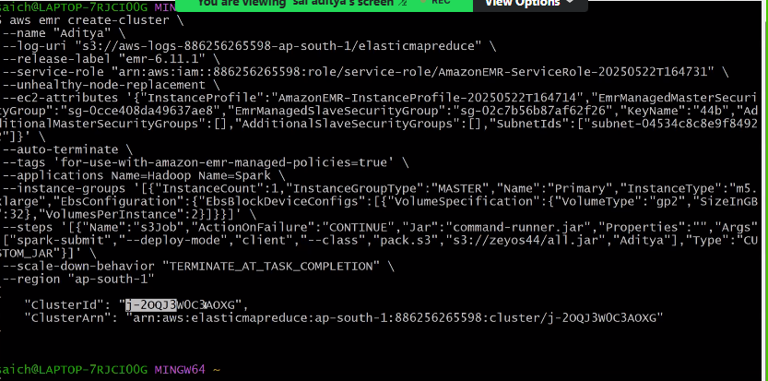
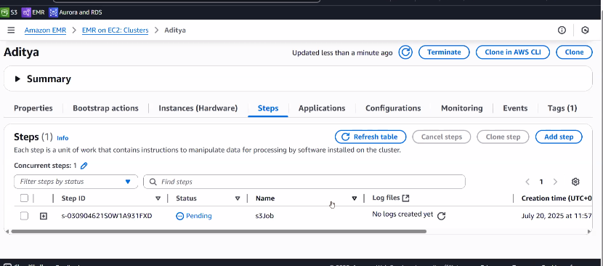
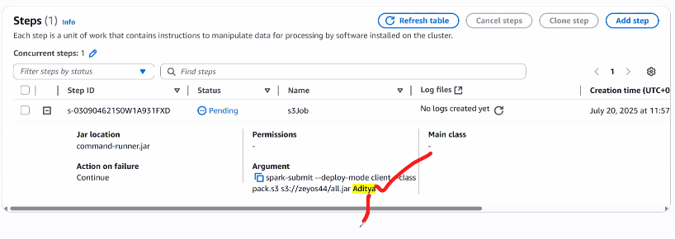
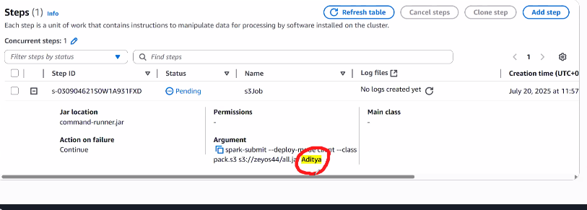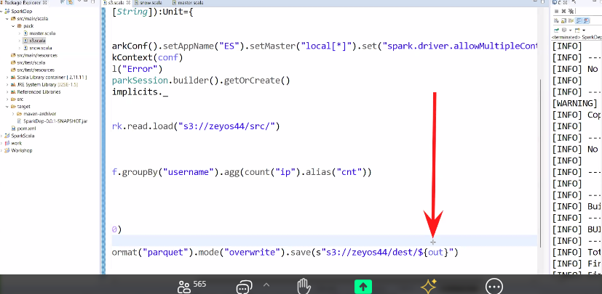
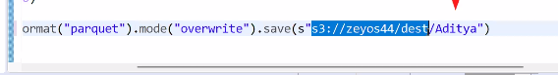
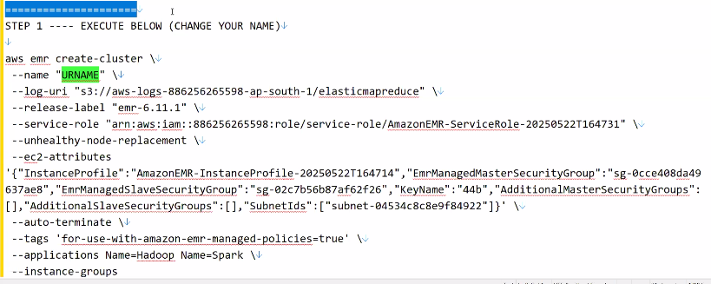
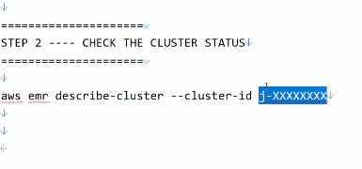
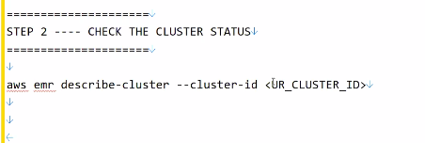
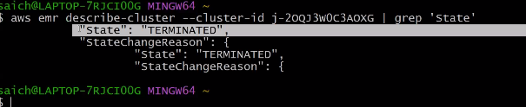
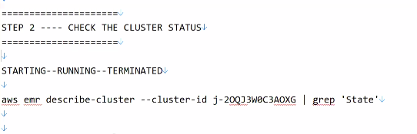
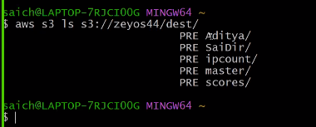
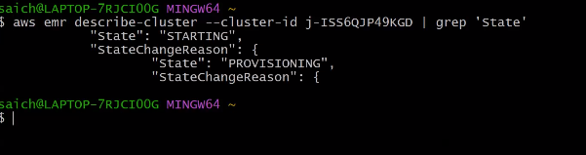
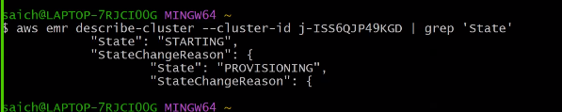
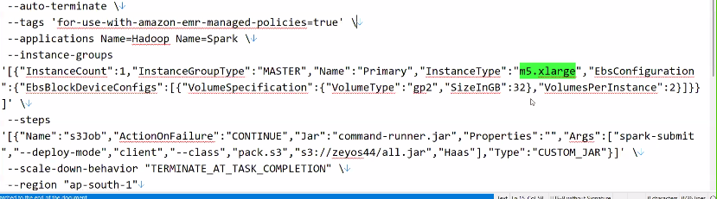
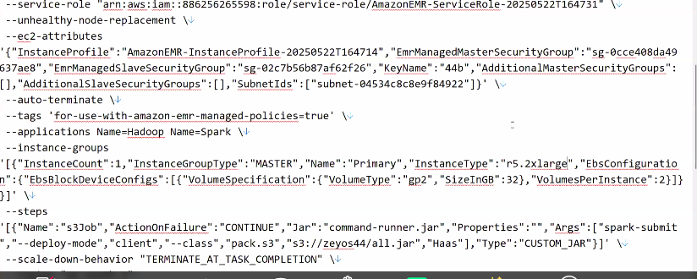
=====================
🔴 STEP 1 ---- EXECUTE BELOW (CHANGE YOUR NAME)
=====================

aws emr create-cluster \
--name "URNAME" \
--log-uri "s3://aws-logs-886256265598-ap-south-1/elasticmapreduce" \
--release-label "emr-6.11.1" \
--service-role "arn:aws:iam::886256265598:role/service-role/AmazonEMR-ServiceRole-20250522T164731" \
--unhealthy-node-replacement \
--ec2-attributes '{"InstanceProfile":"AmazonEMR-InstanceProfile-20250522T164714","EmrManagedMasterSecurityGroup":"sg-0cce408da49637ae8","EmrManagedSlaveSecurityGroup":"sg-02c7b56b87af62f26","KeyName":"44b","AdditionalMasterSecurityGroups":[],"AdditionalSlaveSecurityGroups":[],"SubnetIds":["subnet-04534c8c8e9f84922"]}' \
--auto-terminate \
--tags 'for-use-with-amazon-emr-managed-policies=true' \
--applications Name=Hadoop Name=Spark \
--instance-groups '[{"InstanceCount":1,"InstanceGroupType":"MASTER","Name":"Primary","InstanceType":"m5.xlarge","EbsConfiguration":{"EbsBlockDeviceConfigs":[{"VolumeSpecification":{"VolumeType":"gp2","SizeInGB":32},"VolumesPerInstance":2}]}}]' \
--steps '[{"Name":"s3Job","ActionOnFailure":"CONTINUE","Jar":"command-runner.jar","Properties":"","Args":["spark-submit","--deploy-mode","client","--class","pack.s3","s3://zeyos44/all.jar","URNAME"],"Type":"CUSTOM_JAR"}]' \
--scale-down-behavior "TERMINATE_AT_TASK_COMPLETION" \
--region "ap-south-1"

=====================
🔴 STEP 2 ---- CHECK THE CLUSTER STATUS
=====================

STARTING--RUNNING--TERMINATED

aws emr describe-cluster --cluster-id j-KXXXXXXXXX2 | grep 'State'

=====================
🔴 STEP 3 --
=====================

aws s3 ls s3://zeyos44/dest/

=====================
🔴 STEP 1 ---- EXECUTE BELOW (CHANGE YOUR NAME)
=====================

aws emr create-cluster \
--name "Haas" \
--log-uri "s3://aws-logs-886256265598-ap-south-1/elasticmapreduce" \
--release-label "emr-6.11.1" \
--service-role "arn:aws:iam::886256265598:role/service-role/AmazonEMR-ServiceRole-20250522T164731" \
--unhealthy-node-replacement \
--ec2-attributes '{"InstanceProfile":"AmazonEMR-InstanceProfile-20250522T164714","EmrManagedMasterSecurityGroup":"sg-0cce408da49637ae8","EmrManagedSlaveSecurityGroup":"sg-02c7b56b87af62f26","KeyName":"44b","AdditionalMasterSecurityGroups":[],"AdditionalSlaveSecurityGroups":[],"SubnetIds":["subnet-04534c8c8e9f84922"]}' \
--auto-terminate \
--tags 'for-use-with-amazon-emr-managed-policies=true' \
--applications Name=Hadoop Name=Spark \
--instance-groups '[{"InstanceCount":1,"InstanceGroupType":"MASTER","Name":"Primary","InstanceType":"m5.xlarge","EbsConfiguration":{"EbsBlockDeviceConfigs":[{"VolumeSpecification":{"VolumeType":"gp2","SizeInGB":32},"VolumesPerInstance":2}]}}]' \
--steps '[{"Name":"s3Job","ActionOnFailure":"CONTINUE","Jar":"command-runner.jar","Properties":"","Args":["spark-submit","--deploy-mode","client","--class","pack.s3","s3://zeyos44/all.jar","Haas"],"Type":"CUSTOM_JAR"}]' \
--scale-down-behavior "TERMINATE_AT_TASK_COMPLETION" \
--region "ap-south-1"

=====================
🔴 STEP 2 ---- CHECK THE CLUSTER STATUS
=====================

STARTING--RUNNING--TERMINATED

aws emr describe-cluster --cluster-id j-KXXXXXXXXX2 | grep 'State'

=====================
🔴 STEP 3 --
=====================

aws s3 ls s3://zeyos44/dest/

$ aws emr create-cluster --name "Sivasankar" --log-uri "s3://aws-logs-886256265598-ap-south-1/elasticmapreduce" --release-label "emr-6.11.1" --service-role "arn:aws:iam::886256265598:role/service-role/AmazonEMR-ServiceRole-20250522T164731" --unhealthy-node-replacement --ec2-attributes '{"InstanceProfile":"AmazonEMR-InstanceProfile-20250522T164714","EmrManagedMasterSecurityGroup":"sg-0cce408da49637ae8","EmrManagedSlaveSecurityGroup":"sg-02c7b56b87af62f26","KeyName":"44b","AdditionalMasterSecurityGroups":[],"AdditionalSlaveSecurityGroups":[],"SubnetIds":["subnet-04534c8c8e9f84922"]}' --auto-terminate --tags 'for-use-with-amazon-emr-managed-policies=true' --applications Name=Hadoop Name=Spark --instance-groups '[{"InstanceCount":1,"InstanceGroupType":"MASTER","Name":"Primary","InstanceType":"m5.xlarge","EbsConfiguration":{"EbsBlockDeviceConfigs":[{"VolumeSpecification":{"VolumeType":"gp2","SizeInGB":32},"VolumesPerInstance":2}]}}]' --steps '[{"Name":"s3Job","ActionOnFailure":"CONTINUE","Jar":"command-runner.jar","Properties":"","Args":["spark-submit","--deploy-mode","client","--class","pack.s3","s3://zeyos44/all.jar","Sivasankar"],"Type":"CUSTOM_JAR"}]' --scale-down-behavior "TERMINATE_AT_TASK_COMPLETION" --region "ap-south-1"
{
"ClusterId": "j-39KFI9JP4SLU0",
"ClusterArn": "arn:aws:elasticmapreduce:ap-south-1:886256265598:cluster/j-39KFI9JP4SLU0"
}

Siva@DESKTOP-0L0RSBR MINGW64 ~ (master)
$ aws emr describe-cluster --cluster-id j-39KFI9JP4SLU0 | grep 'State'
"State": "STARTING",
"StateChangeReason": {
"State": "BOOTSTRAPPING",
"StateChangeReason": {

Siva@DESKTOP-0L0RSBR MINGW64 ~ (master)
$ aws emr describe-cluster --cluster-id j-39KFI9JP4SLU0 | grep 'State'
"State": "STARTING",
"StateChangeReason": {
"State": "BOOTSTRAPPING",
"StateChangeReason": {

Siva@DESKTOP-0L0RSBR MINGW64 ~ (master)
$ aws emr describe-cluster --cluster-id j-39KFI9JP4SLU0 | grep 'State'
"State": "STARTING",
"StateChangeReason": {
"State": "BOOTSTRAPPING",
"StateChangeReason": {

Siva@DESKTOP-0L0RSBR MINGW64 ~ (master)
$ aws emr describe-cluster --cluster-id j-39KFI9JP4SLU0 | grep 'State'
"State": "RUNNING",
"StateChangeReason": {
"State": "RUNNING",
"StateChangeReason": {

Siva@DESKTOP-0L0RSBR MINGW64 ~ (master)
$ aws emr describe-cluster --cluster-id j-39KFI9JP4SLU0 | grep 'State'
"State": "RUNNING",
"StateChangeReason": {
"State": "RUNNING",
"StateChangeReason": {

Siva@DESKTOP-0L0RSBR MINGW64 ~ (master)
$ aws emr describe-cluster --cluster-id j-39KFI9JP4SLU0 | grep 'State'
"State": "TERMINATING",
"StateChangeReason": {
"State": "TERMINATING",
"StateChangeReason": {

Siva@DESKTOP-0L0RSBR MINGW64 ~ (master)
$ aws emr describe-cluster --cluster-id j-39KFI9JP4SLU0 | grep 'State'
"State": "TERMINATING",
"StateChangeReason": {
"State": "TERMINATING",
"StateChangeReason": {

Siva@DESKTOP-0L0RSBR MINGW64 ~ (master)
$ aws emr describe-cluster --cluster-id j-39KFI9JP4SLU0 | grep 'State'
"State": "TERMINATED",
"StateChangeReason": {
"State": "TERMINATED",
"StateChangeReason": {

Siva@DESKTOP-0L0RSBR MINGW64 ~ (master)
$ aws s3 ls s3://zeyos44/dest/
PRE ASLAM/
PRE Aditya/
PRE Amir/
PRE Ashok8099949061/
PRE Deepika/
PRE Dhivya Rubini/
PRE Gokula Dinesh/
PRE Haas/
PRE Hamdhan/
PRE JAI/
PRE Kathir/
PRE Kunika/
PRE Laknair/
PRE PRIYANKAK/
PRE Rajath/
PRE SaiBalaji/
PRE SaiDir/
PRE Shrikantha/
PRE Sivasankar/
PRE SriniSelvam09/
PRE TARA/
PRE URNAME/
PRE Vaishnavi/
PRE Vivek/
PRE anandp/
PRE anil_709/
PRE ipcount/
PRE mariyam/
PRE master/
PRE scores/
PRE sudheersk215/

